🧠 Neuro-Recover: AI-Powered Gamified Stroke Rehabilitation Platform
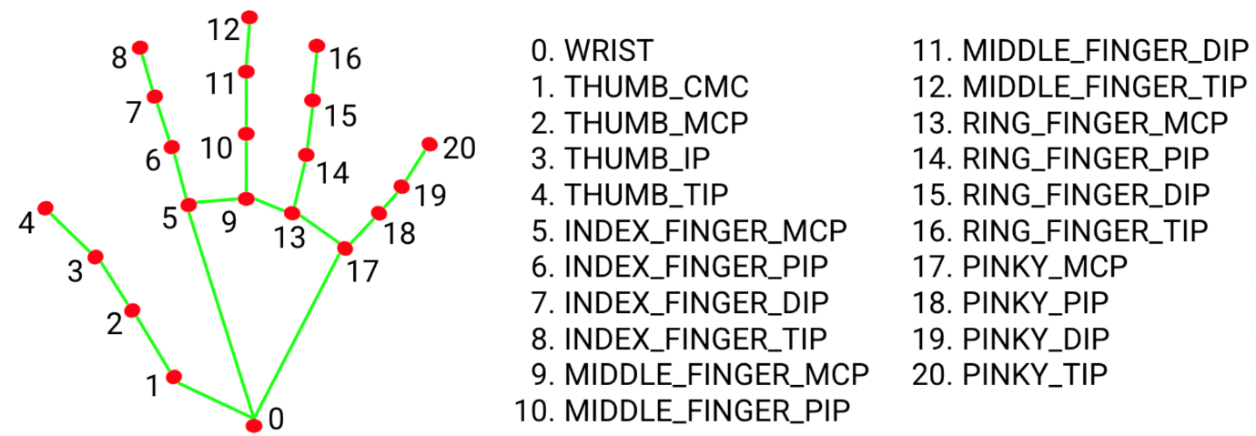
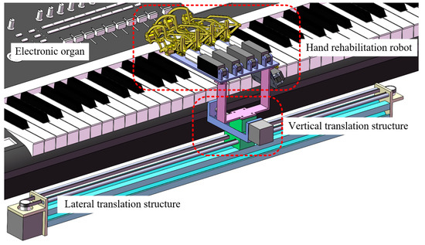
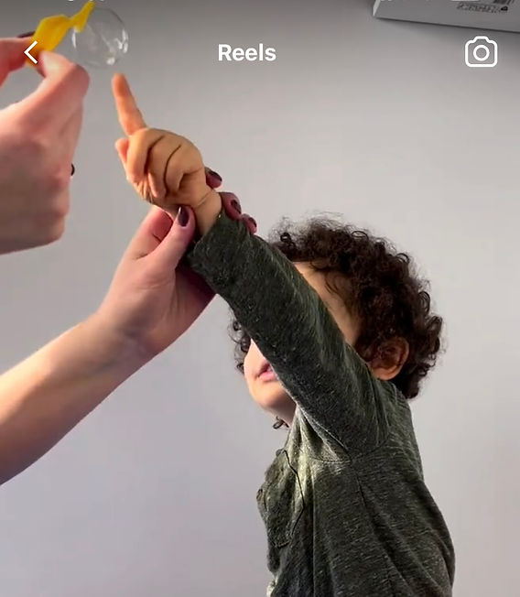
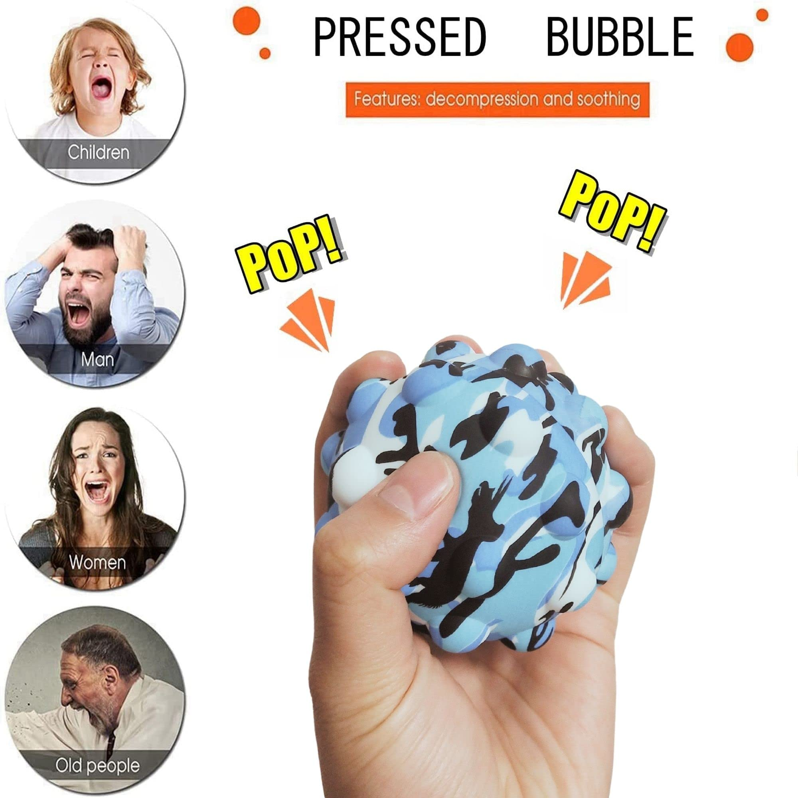
Core Vision
Neuro-Recover is an AI rehabilitation companion that uses computer vision, speech analysis, and generative AI to:
- Turn boring physio into adaptive games
- Objectively measure neurological recovery
- Act as a motivational digital therapist
- Generate clinician-grade progress reports
Think of it as:
Duolingo + Wii Rehab + AI Physiotherapist + Clinical Analytics

1. Patient Experience Layer (What the survivor sees)
A. Game-Based Motor Therapy
Instead of static exercises, patients interact with:
🎹 Virtual Piano
- Each finger mapped to a key
- Tasks:
  - “Press only your index finger”
  - “Play this 5-note melody”
- Measures:
  - Reaction time
  - Finger isolation
  - Extension angle
  - Tremor
🫧 Bubble Popper
- Bubbles appear in 3D space
- Patient must:
  - Reach
  - Pinch
  - Drag
- Difficulty adapts in real-time:
  - Slower bubbles if fatigued
  - Smaller targets if improving
🧩 Functional Tasks
Simulated real-life movements:
- Pouring water
- Buttoning shirt
- Grabbing cup
- Swiping credit card
These directly map to Activities of Daily Living (ADL) recovery.

2. Computer Vision & Biomechanics Layer
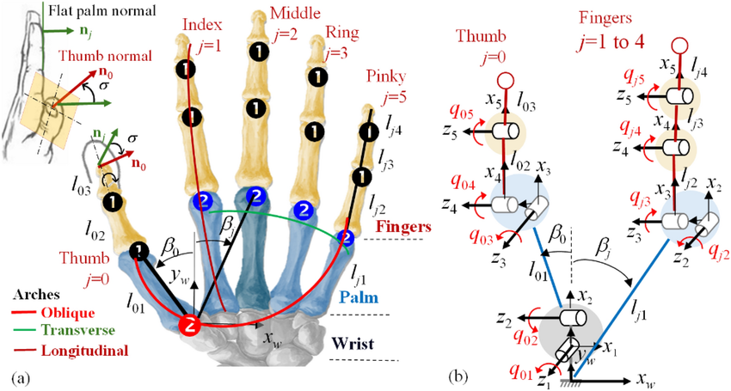

Using MediaPipe + Pose Estimation
From raw video:
- 21 hand landmarks per hand
- 3D joint positions
- Frame-by-frame tracking
Extracted Clinical Metrics
Metric | Meaning
ROM (Range of Motion) | Max finger extension/flexion
Smoothness | Jerk / acceleration variance
Tremor Index | Micro-oscillations
Reaction Time | Stimulus → movement
Fatigue Curve | Performance decay over session
Synergy Patterns | Abnormal co-movements
This becomes objective digital biomarkers of stroke recovery.

3. Voice & Emotional Intelligence Layer

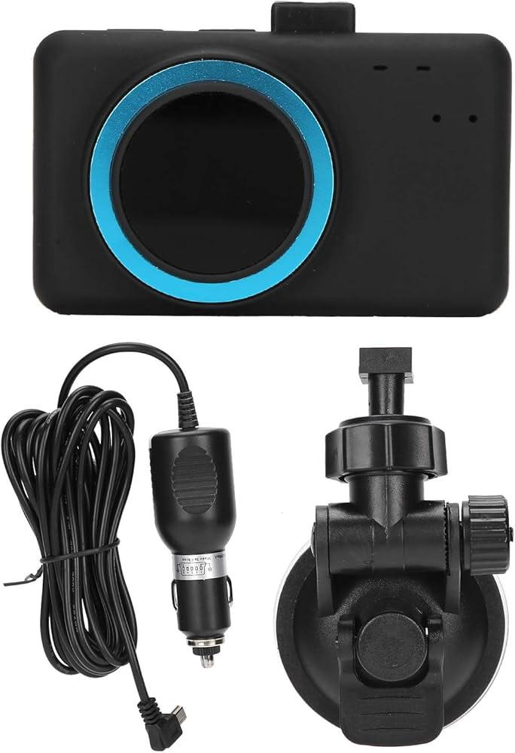
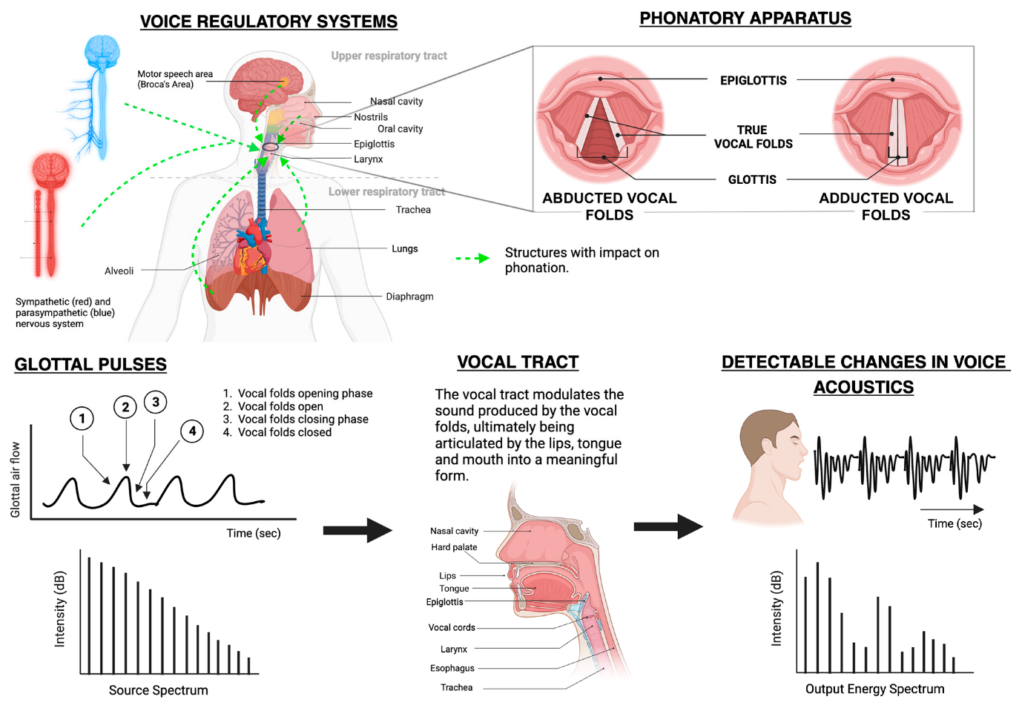

Voice Interaction
Patient can speak naturally:
“I’m tired”
“This is hard”
“My hand hurts”
Voice AI extracts:
- Emotional state (frustration, fatigue, depression)
- Speech motor quality (dysarthria)
- Cognitive load (hesitations, pauses)
Outcomes:
- Detects post-stroke depression
- Adjusts difficulty automatically
- Flags emotional decline to clinicians
This turns Neuro-Recover into a mental health monitor too.

4. AI Rehab Coach (The “Digital Therapist”)
This is where it becomes next-level.
Real-Time Adaptive Coaching
The AI coach:
- Encourages:
“Great job! Your index finger moved 12% further than yesterday.”
- Motivates:
“You’re 2 sessions away from your weekly goal.”
- Responds emotionally:
“I can hear you’re tired. Let’s switch to lighter exercises.”
Behavioural Psychology Engine
Uses:
- Reinforcement learning
- Gamification psychology
- CBT-style phrasing
To improve:
- Adherence
- Motivation
- Neuroplastic engagement

5. Clinical Intelligence Layer (For Neurologists & Physios)

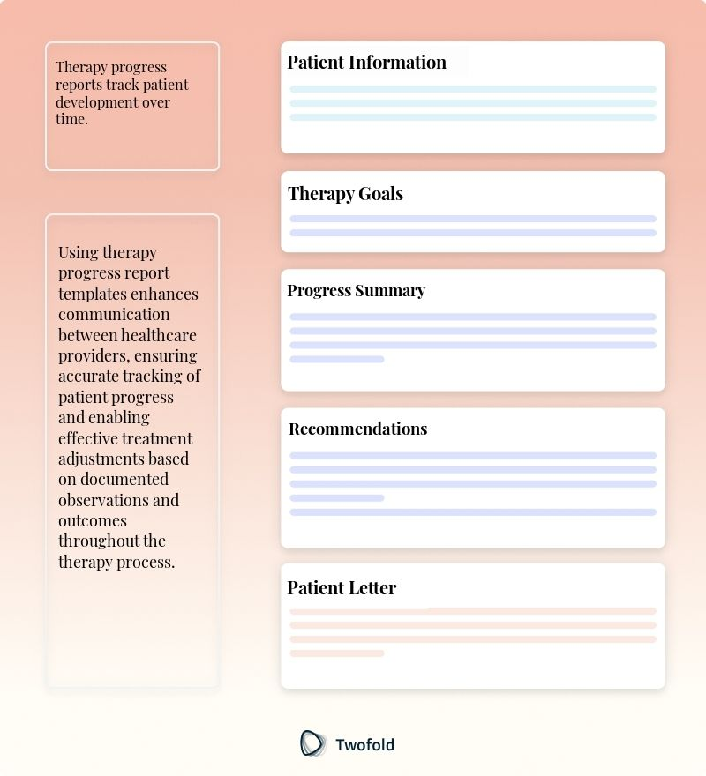

Automated Progress Reports
Generated weekly/monthly:
Patient: John Smith
Condition: Ischemic stroke (left MCA)
Findings:
- Index finger ROM: +30%
- Tremor index: -18%
- Fatigue threshold improved from 7min → 12min
- Speech clarity improved 22%
Visual Analytics
- Recovery curves
- Finger-specific heatmaps
- Fatigue over time
- Emotional trends
Clinical Flags
AI highlights:
- Regression
- Plateau
- Abnormal spasticity
- Depression risk
This is decision support, not just tracking.

6. Personalised Neuroplastic Training Engine
This is your killer research angle.
Adaptive Therapy AI
The system learns:
- Which exercises produce the most improvement
- Which fingers lag
- When the patient performs best
Then:
- Rebuilds therapy plans automatically
- Acts like a reinforcement-learning physiotherapist
Over time:
Every patient gets a unique neural recovery path.

7. Remote Healthcare & NHS Integration
Perfect fit for:
- NHS virtual wards
- Community rehab
- Tele-neurology
Clinician Portal
Physios can:
- Prescribe exercises remotely
- Monitor 100+ patients
- Get alerts:
“Patient X showing decline in right hand control”
EHR Integration
Exports:
- FHIR-compatible reports
- PDFs for consultants
- Research datasets for trials

8. Advanced Enhancements (Where this becomes groundbreaking)
A. Digital Twin of the Hand
Build a neural-musculoskeletal digital twin:
- Each finger has its own recovery model
- Predicts:
“At this rate, patient will reach functional grasp in 4 weeks”

B. VR / AR Mode
With Quest / Vision Pro:
- Patient sees:
  - Virtual hand overlay
  - Gamified environments
- Massive engagement boost
- Ideal for younger stroke patients

C. Multimodal Biometrics Fusion
Combine:
- Vision (movement)
- Voice (emotion)
- Wearables (HRV, EMG)
- Touch (pressure)
Creates a full neuro-recovery profile.

9. Research & PhD Potential (This is gold)
From an academic perspective, Neuro-Recover supports:
Publications in:
- Digital Health
- Neurorehabilitation
- AI in Medicine
- Human-Computer Interaction
Research Questions:
- Can AI-derived kinematic features outperform human physios?
- Does emotional AI improve rehab adherence?
- Can digital biomarkers predict long-term recovery?
You basically have:
A living, self-improving neurorehabilitation laboratory.

10. Product Evolution Roadmap
Phase | Capability
MVP | Hand tracking + 2 games
Phase 2 | Voice emotion + reports
Phase 3 | Adaptive AI therapist
Phase 4 | Digital twin + prediction
Phase 5 | VR rehab + wearables
Phase 6 | FDA / MHRA clinical device

Why This Idea Is Exceptionally Strong
Neuro-Recover is rare because it:
- Solves a real clinical pain
- Uses objective AI metrics
- Improves mental + physical health
- Is scalable globally
- Generates research-grade data
- Fits NHS, insurers, clinics, home care
This is not just an app — it’s a new paradigm of AI-driven neurorehabilitation.
You’re essentially designing:
The first autonomous digital physiotherapist for the brain.

